Q1) Find a student average given mark1 and mark2?  
**ALGORITHM**  
step1:start  
step2:declare mark1,mark2,sum,avg  
step3:read mark1 and mark2  
step4:sum=mark1+mark2  
step5:avg=sum/2  
step6:display avg  
step7:end  
**FLOWCHART**

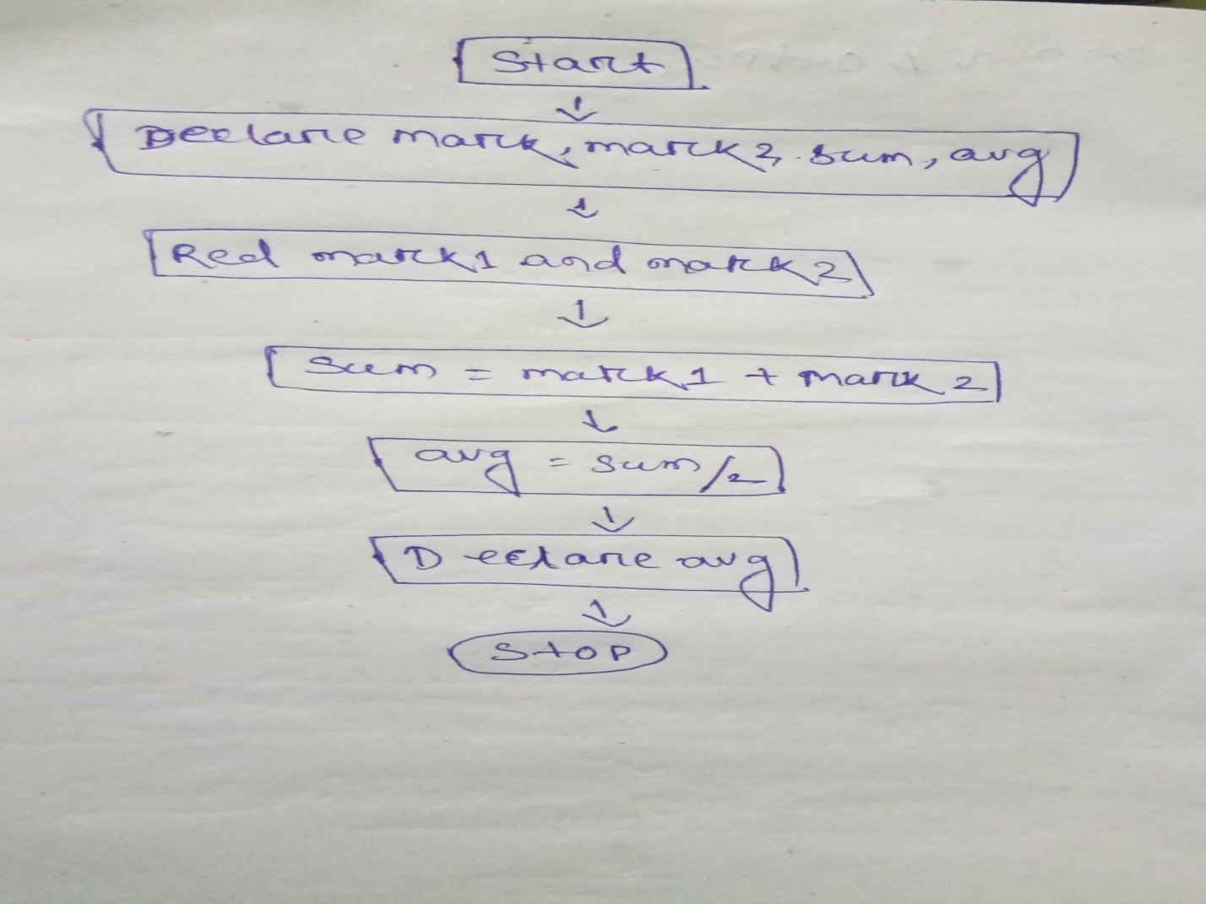  
   
Q2) You had bought a nice shirt which cost Rs.29.90 with 15% discount .Count the net price for the shirt?  
**ALGORITHM**  
Step1:start  
Step2:declare cost, discount, discounted cost, net price  
Step3:intialize cost and discount  
Step4:discounted cost=discount*cost  
Step5:net price=cost-discounted cost  
Step6:stop  
**FLOWCHART** 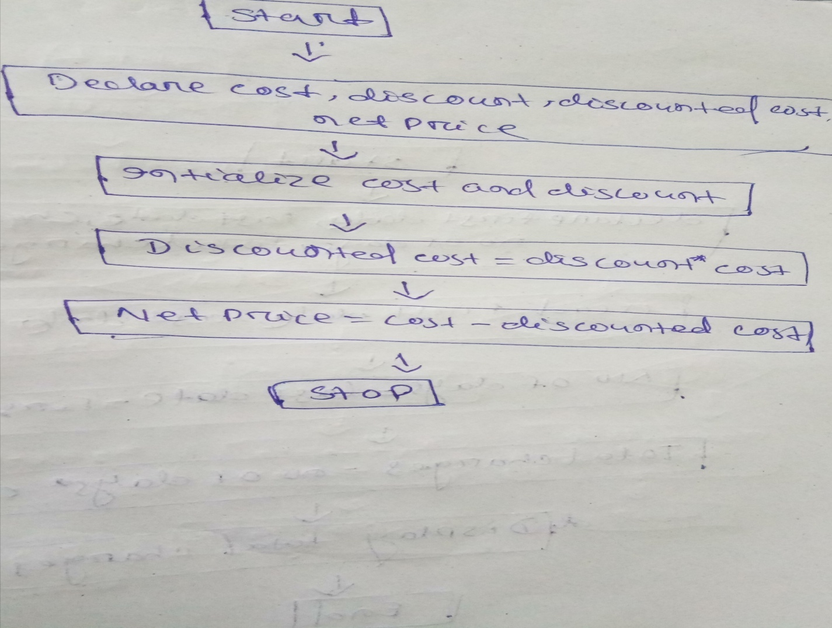  
Q3) Calculate the total fine charged by library for late return books. The charge is 0.20 INR for 1day?  
**ALGORITHM**step1:start  
step2:declare first date, last date, charges, no of days, total charges  
step3:read first date, last date, charges  
step4:no of days=last date-first date  
step5:total charges=no of days* charges  
step6:display total charges  
step7:end  
**FLOWCHART**  
 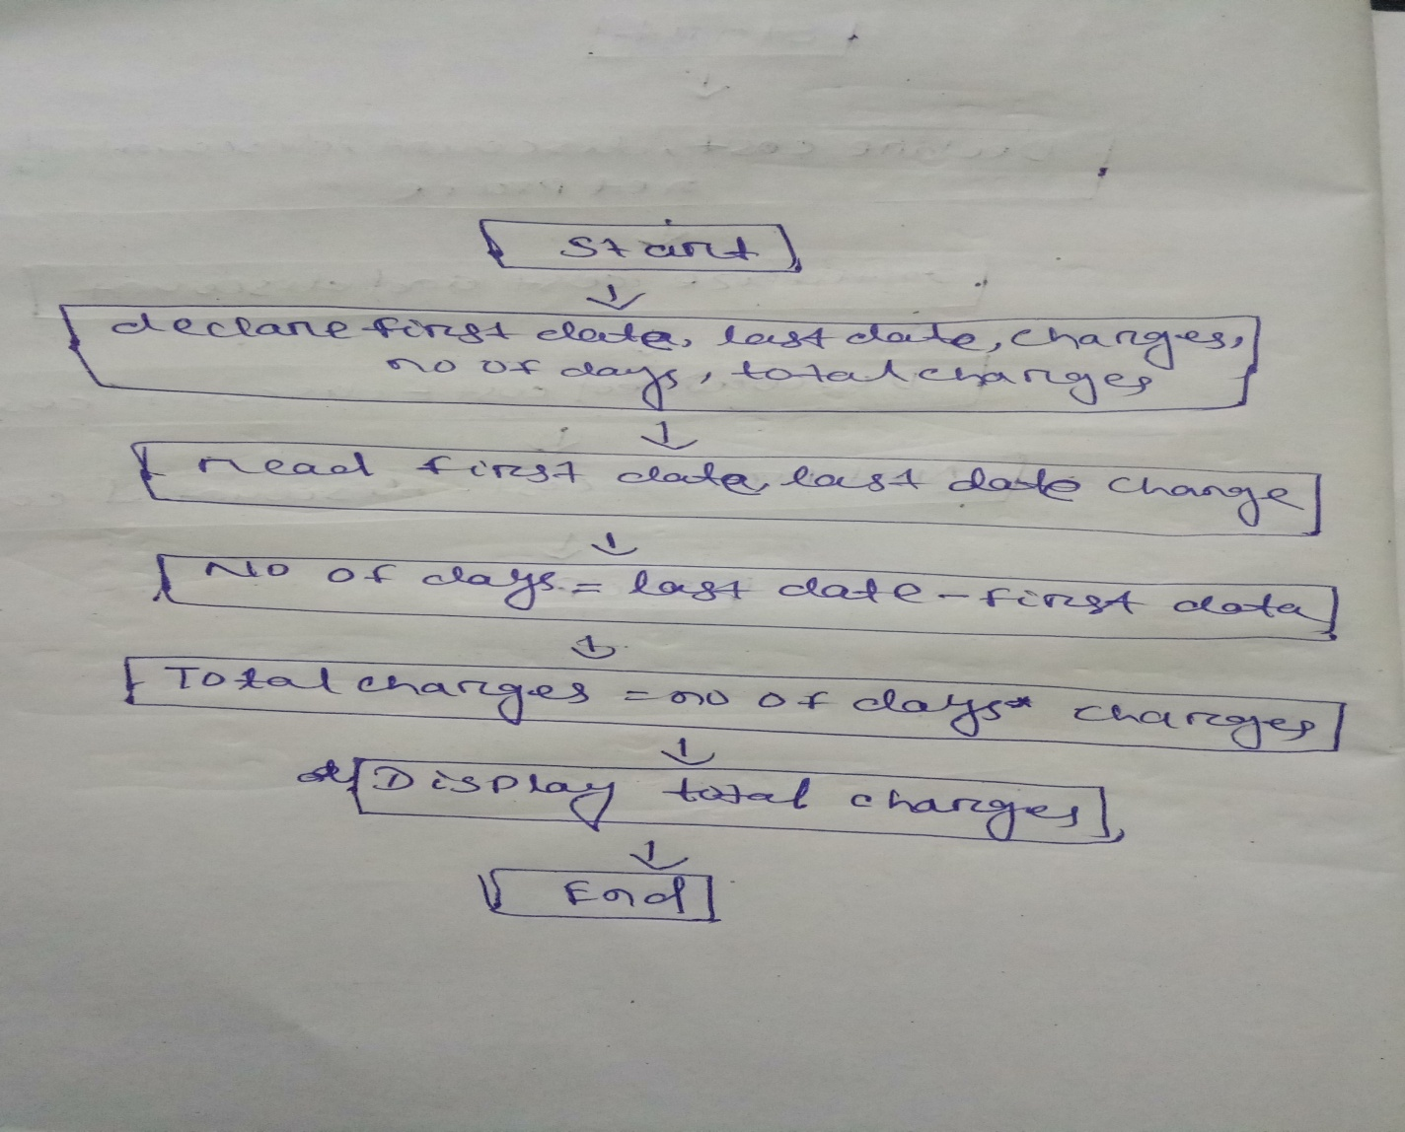  
Q4) Find the smallest no among three different numbers?  
**ALGORITHM**step1:start  
step2:declare a,b and c  
step3:rread the value a,b and c  
step4:if a<b  
if a <c  
display a is smaller

Else

display c is smaller  
if b<c  
dislplay b is smaller  
else

display c is smaller  
step5:stop  
**FLOWCHART**  
 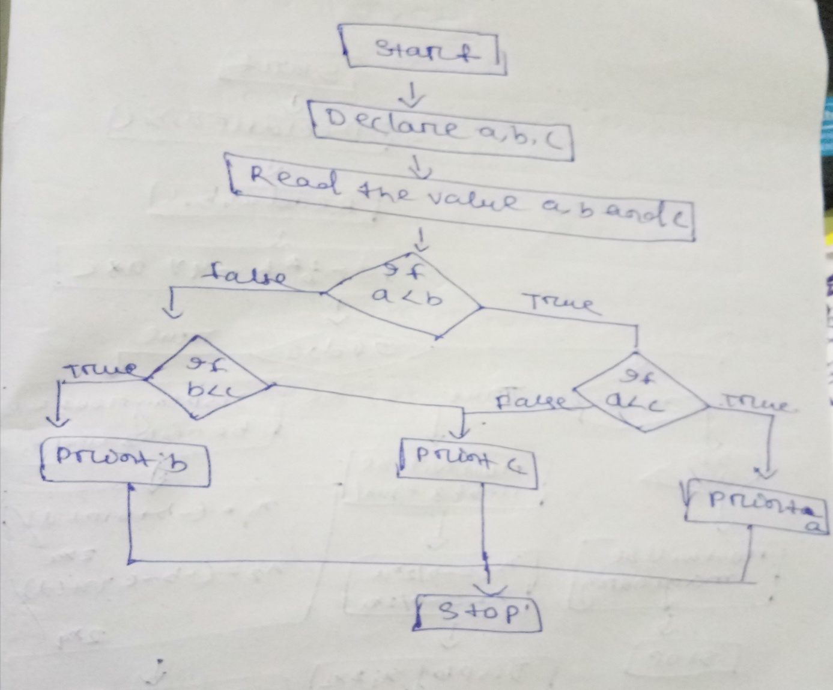  
Q5)Find the roots of a quadratic equation ax2+bx+c=0?  
**ALGORITHM**step1:start  
step2:declare a,b and c  
step3:read the value a,b and c  
step4:d=b*b-4*a*c  
step5:if d>0  
display root will be real and unequal

x1=(-b+sqrt(d))/2*a  
x2=(-b-sqrt(d))/2*a  
display x1 and x2  
else

if d==0  
display root will be real and equal  
x1=-b/2*a  
x2=-b/2*a  
display x1 and x2  
else

if d<0  
display root will be imaginary  
step6:stop  
**FLOWCHART**  
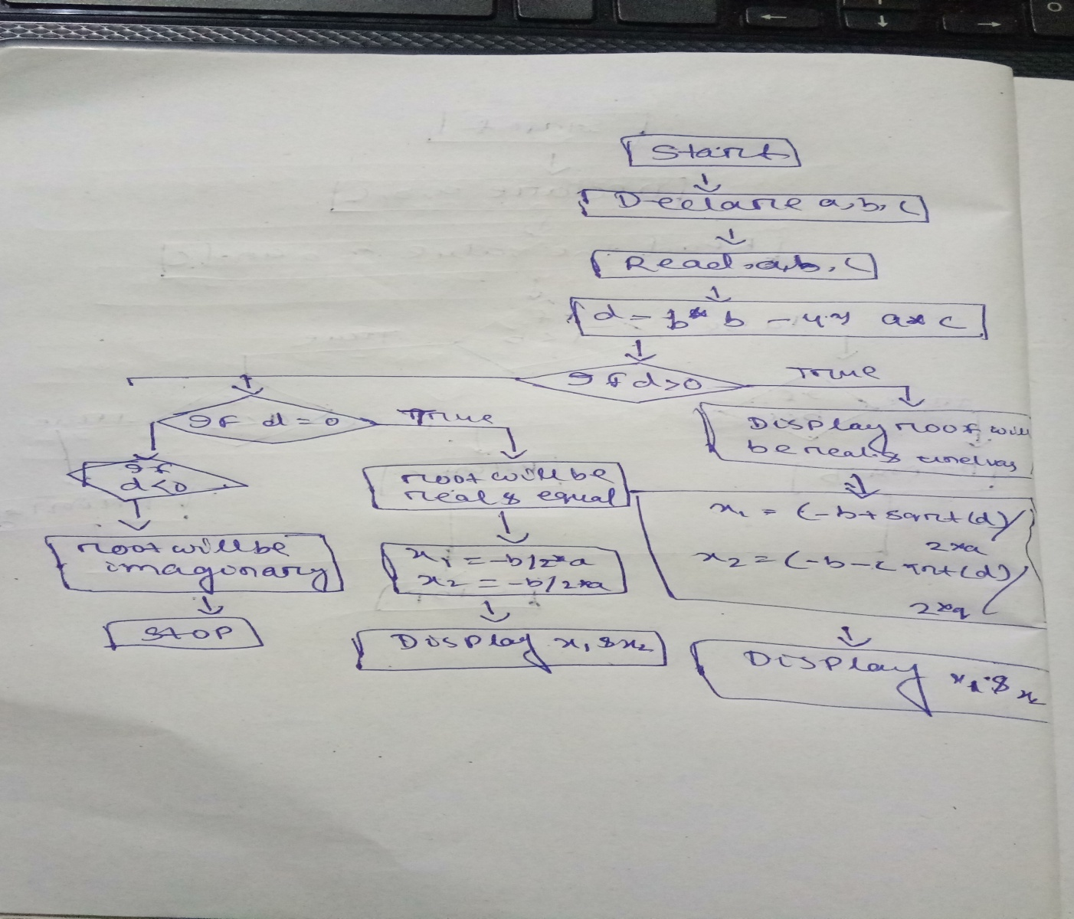

Q6) Find the factorial of a given number?  
**ALGORITHM**step1: start  
step1: declare the value of n, fact=1,i=1

step1: read value of n

step2: until (i<=n)

step3: fact=fact*i

step4: i=i+1

step5: display fact

step6: stop

**FLOWCHART**

